Cookie Dough Fundraisers Nutritional Information

Chocolate Chip

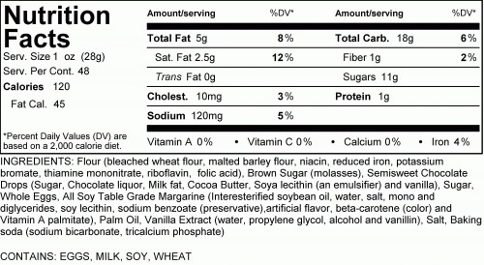

M&M Cookie
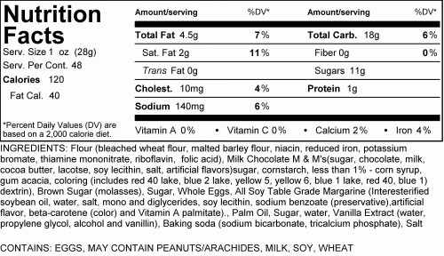

Oatmeal Raisin
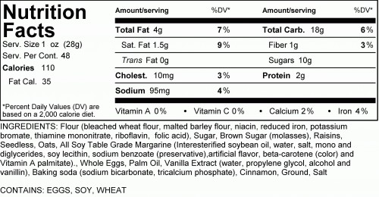

White Chocolate Macadamia Nut
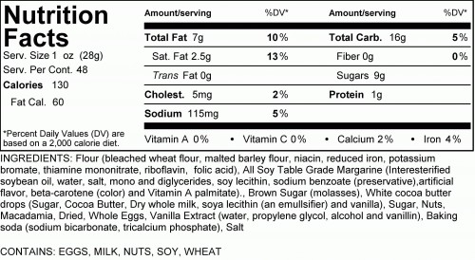

Triple Chocolate
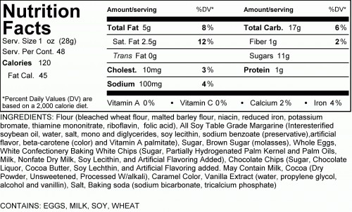

Peanut Butter
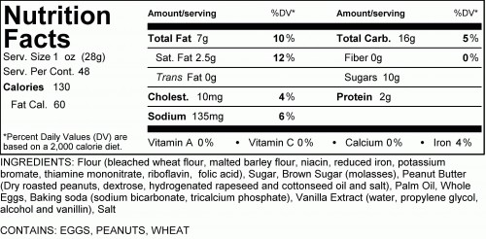

Monster Cookie
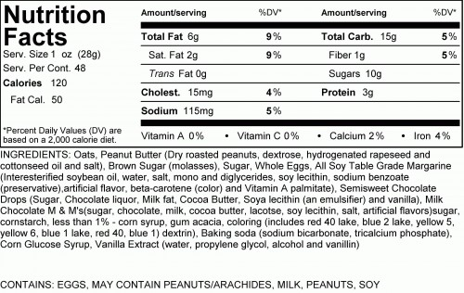

Cranberry White Chocolate Oatmeal
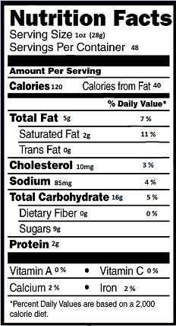
Ingredients: Flour (Bleached Wheat Flour, Malted Barley Flour, Niacin, Reduced Iron, Potassium Bromate, Thiamine Mononitrate, Riboflavin, Folic Acid), Sugar, Oats, White Cocoa Butter Drops ( Sugar, Cocoa butter, Dry Whole Milk, Soy Lecithin [an Emulsifier] and Vanilla), Dried Sweetened Cranberries (Cranberries, Sugar, Sunflower Oil), All Soy Table Grade Margarine (Interesterified Soybean Oil, Water, Salt, Mono and Diglycerides, Soy Lecithin, Sodium benzoate [Preservative], Artificial Flavor, Beta-Carotene [Color], and Vitamin A Palmitate), Palm Oil, Brown Sugar (Sugar, Molasses), Whole Eggs, Invert Sugar (Sugar, Water), Vanilla Extract (Water, Propylene Glycol, Alcohol And Vanillin), Baking Powder ( Sodium, Bicarbonate, Tricalcium Phosphate), Salt
Contains: Milk, Eggs, Soy Wheat

