Cheesecake Nutritional Information

4-in-1 Ultimate Cheesecake Chocolate Pie
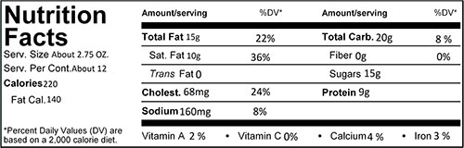
Ingredients:
Cream cheese, whole eggs, shortening, graham crumbs, chocolate, heavy cream, brown sugar, butter blend, corn starch, vanilla, salt, lemon juice.

